

Community Gardens: Growing Great Groups
10am Saturday 13th - 4pm Sunday 14th August 2011
Optional evening activity on the Saturday night
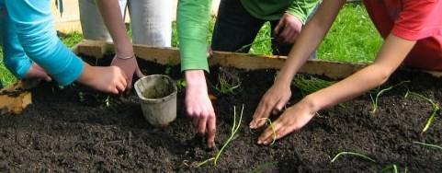
This is a workshop for people involved in community gardens who want to reflect on the 'back-end' of community gardening and develop their own group's ability to work together in ways that are effective and empowering.

This gathering aims to:
- Explore organisational structures and decision making processes that encourage active democratic participation
- Grow participants meeting facilitation and group process skills
- Examine how community gardening groups can maintain momentum long term
- Explore possibilities for coalition building and collaboration

This workshop is for people who actively involved in community gardens' decision making groups. The workshop has a particular focus on the Whanganui-a-Tara/Wellington region, but community gardens from throughout the country are welcome to attend.

The workshop will involve small group work focusing on the community gardens that participants are involved in. Therefore, we strongly encourage participants to attend in groups of three or more who are part of the same community garden project.

Venue: The workshop will be Bandoliers building at the Innermost Community Garden in Mount Victoria, Wellington. Food is provided. If you need assistance with travel or with billeting if you are from out of town, please contact us and we will try to help.

Cost: $0-$150 sliding scale for each workshop. Please self-assess your payment and consider your means when deciding what to pay.

Registration: Please register as soon as possible and no later than Friday the 29th of July. Spaces are limited so get in quick!

For more information and to register, please contact Tanya Newman
at education@kotare.org.nz or (09) 551 7765

